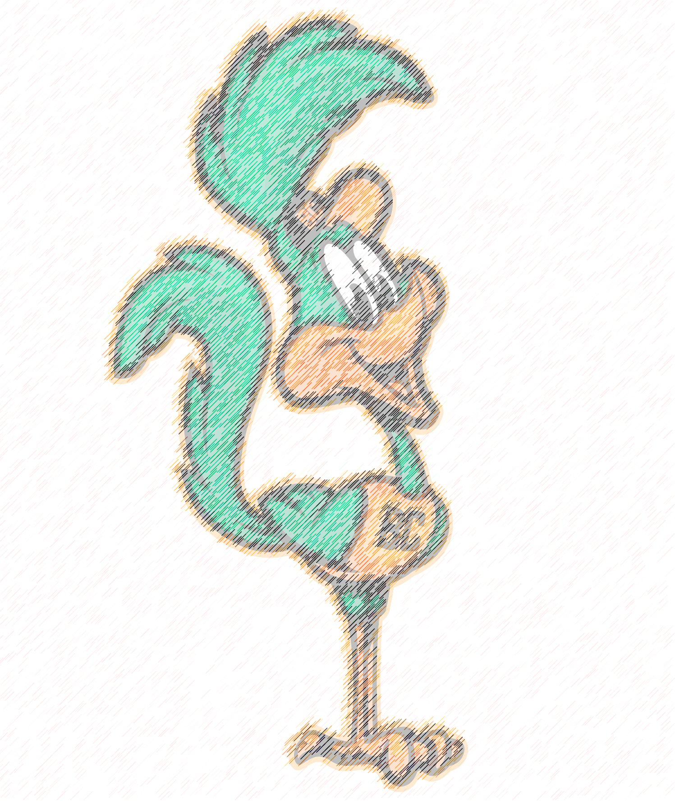 [**3rd Grade**]

**Classroom Schedule**

**Barton Chapel Elementary**

|  |  |  |
| --- | --- | --- |
| **Duration** | **Time** | **Activity** |
| **30 Mins** | **7:50-8:20** | **Arrival/Breakfast** |
| **`30 Mins** | **8:20-8:50** | **ELA Intervention** |
| **30 Mins** | **8:50-9:20** | **Math Intervention** |
| **60 Mins** | **9:20-10:20** | **ELA**  **Fundations 9:20-9:50**  **Growing Readers 9:50-10:20** |
| **45 Mins** | **10:20-11:05** | **Specials** |
| **40 Mins** | **11:05-11:45** | **ELA** |
| **30 Mins** | **11:45-12:15** | **Lunch** |
| **30 Mins** | **12:15-12:45** | **Writing** |
| **15 Mins** | **12:45-1:00** | **Recess** |
| **70 Mins** | **1:00-2:10** | **Math**  **Number Talks 1:00 to 1:10** |
| **30 Mins** | **2:10-2:40** | **Science/S.S.** |
| **20 Mins** | **2:40-3:00** | **SEL** |
|  | **3:00** | **Dismissal** |

